

CS4051NI/CC4059NI Fundamentals of Computing

70% Individual Coursework
Final

2024/25 spring

Student Name: Sinan Budhathoki
London Met ID: 204046507
College ID: NP01NT4A240181
Assignment Due Date: Thursday, May 15, 2025
Assignment Submission Date: Saturday, April 19, 2025
Word Count: 466
Project File Links:
Onedrive Drive Link: | Keep Google Drive URL of your Project Here with Anyone in Organization can View Option Enabled

I confirm that I understand my coursework needs to be submitted online via MySecondTeacher under the relevant module page before the deadline in order for my assignment to be accepted and marked. I am fully aware that late submissions will be treated as non-submission and a marks of zero will be awar

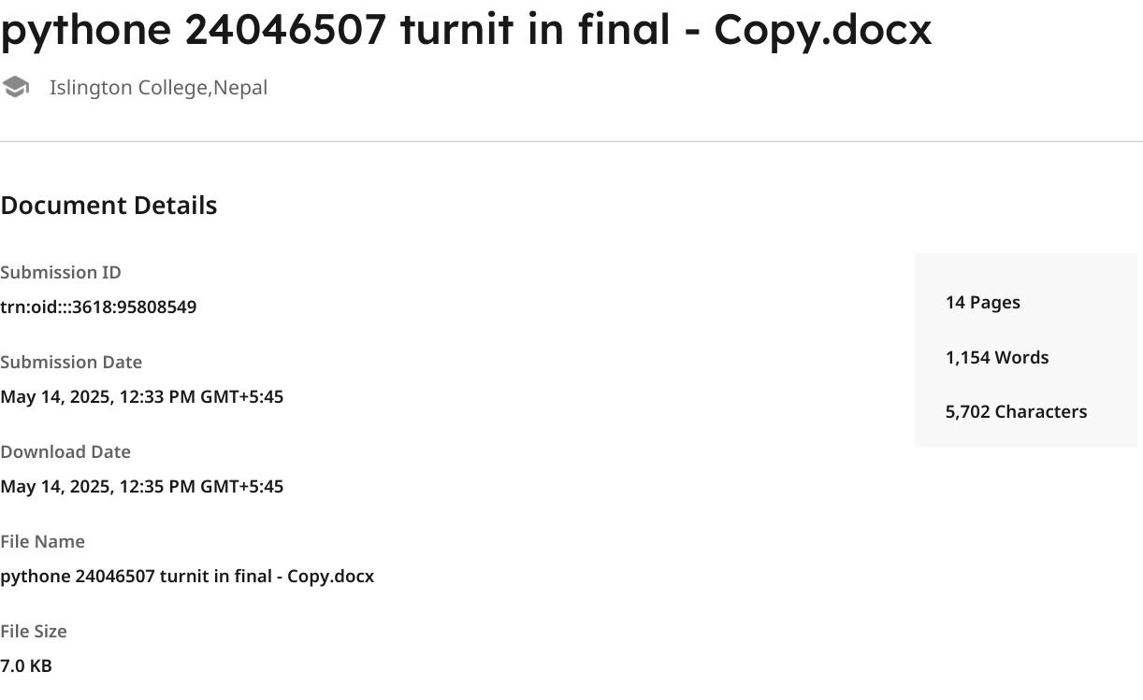

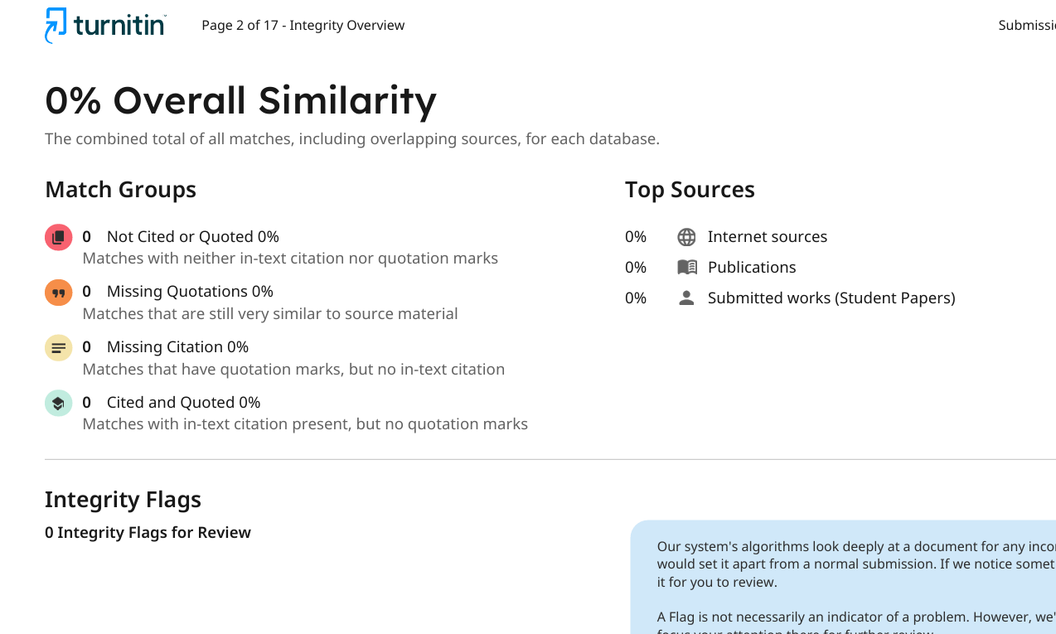
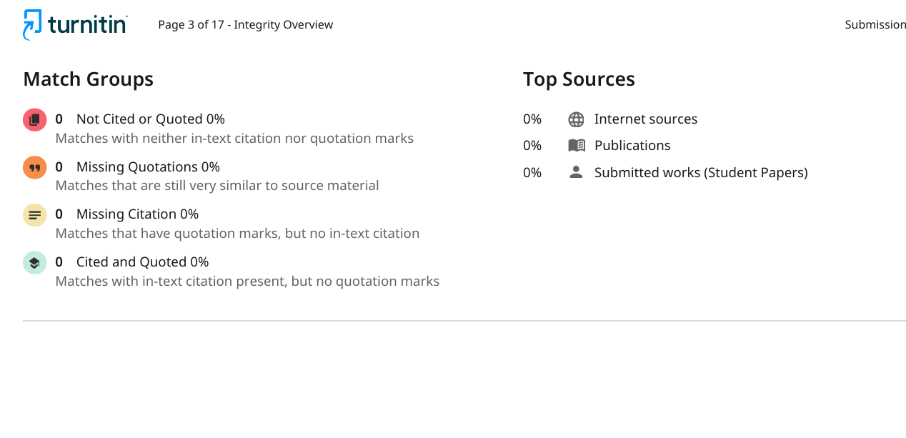
Table of Contents
1. Introduction 1
1.1 Aims and objective 1
1.2 Technology used 1
Python 1
Microsoft Word 3
Draw.io 3
2. Discussion and Analysis 4
2.1Data Structure 4
i. Lists 4
ii. String 5
iii. Float and Integer 5
iv. Dictionary 6
iv. Tuples 6
v. Sets 7
3. Program 7
3.1 Implementation 7
Algorithm 9
Pseudo Code 10
Main.py 10
Operations.py 10
Write.py 11
Read.py 11
Flow Chart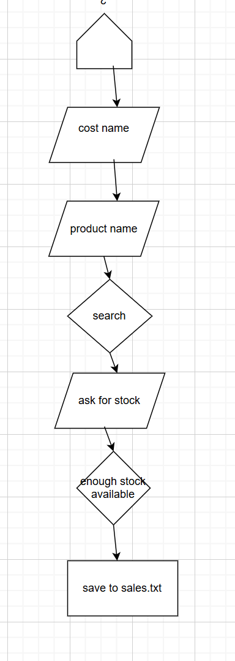 13

1. Introduction

In this project of python we are going build an application for our sales system for we care, which is our local beauty and skin care selling shop .This system will be able to track the products along with it will also be able to apply seasonal discounts in festival or new year and at last it will be able to generate invoices which will make our work more swift for the both customers and store .These systems extraordinary by 3 get one free policy will be supported by dynamic stock updating and exact pricing calculation .This system will monitor the data of the product from the text file. It will display the product along 200 percent mark-ups in the price. It will process transactions along with applying promotions along with updating the stock in real time .Last but not the least it will be able to form invoices with details for the customers and will help in restocking process. This structure will help the user to reduce the errors making the tool effective for the small business.

1.1 Aims and objective

- Boost efficiency = Stablishing automatic updates.
- Refine sales= Applying discounts neatly.
- Enhance clarity = Giving the correct detailed invoice to the customers.
- Secure accuracy = Avoiding stock errors with the help of real-time updates.


1.2 Technology used

Python
Python is a very strong programming language which is widely used in todays era . It was developed by Gudio Van Possam .Pythom comparatively is easy to learn and used compaired to other programming language as well as its versatile.In this project we used 3.13.2 version.

IDLE
It is generally known as integrated development and learning environment is a type of editor which is available with lots of bundle with python. It is considered as beginner friendly anf it has simple and clean interface.

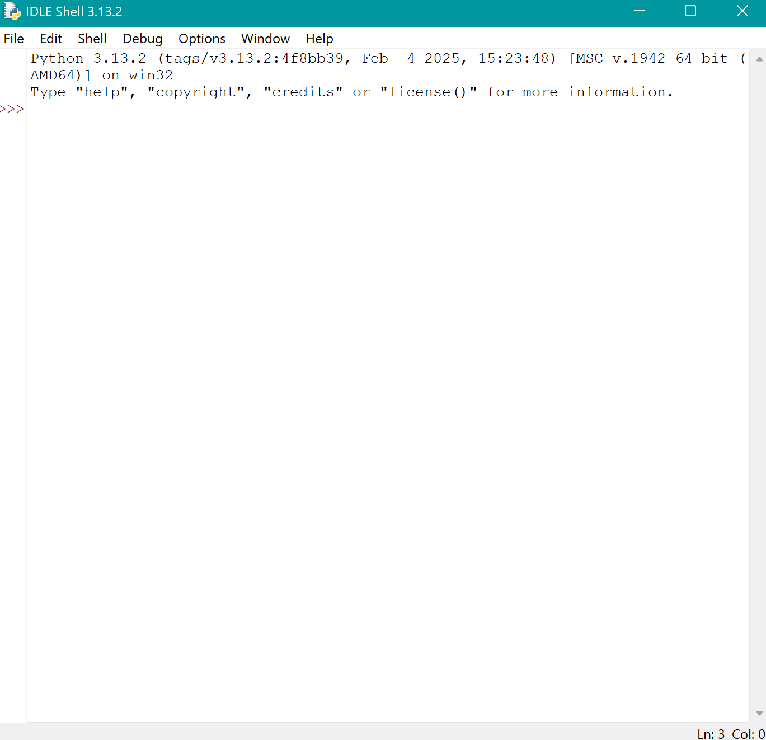

Microsoft Word
Microsoft is a type of soft ware which is used to make documents anf edit text . In this project we used Microsoft word for documentation of our project . It is also used as a text editor .



Draw.io
It is a type of software ehich is used to make diagram such as wireframe ,flow chart , mind mappinf it is the most liked software among the students cause is an open source and easy to use . we used it to make flow chart in our project .



2. Discussion and Analysis

2.1Data Structure

In the data structure Data is obtained from the help of text file products.txt and handed to store data of the product. To operate and manage or alter the data Lots of data structures are used they are mentioned below.

i. Lists

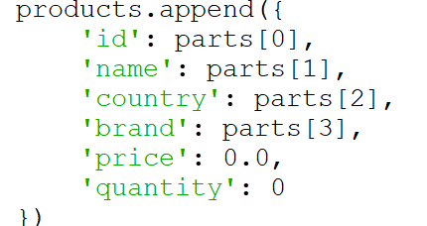
It is a type of complex data structure .The primary data applied in the program is the list Each and every data stored in this list, which is current product. The product lists are also stored in the other list called product_ list .This list is also called nested list.

ii. String

It is a type of primitive data structure the string is usually used for holding data like product id, country, as well as brand .String is usually used for alphabets. The data present in the file is identified as string, then divided by string method like strip as well as split.
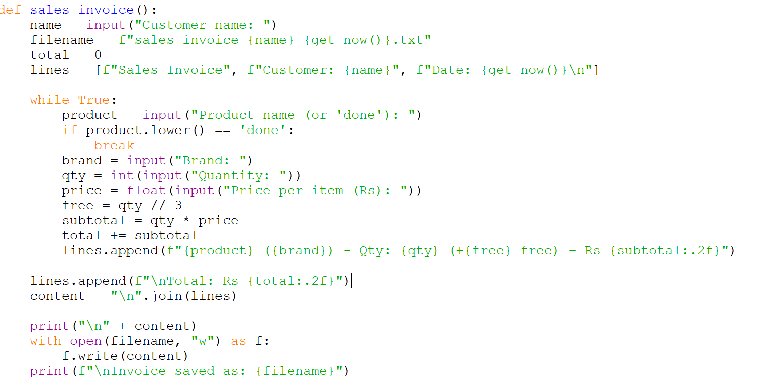

iii. Float and Integer

This is also known as primitive data structure this data structure are used primarily for price of the product, which is integer. And later on, convert it to float and the quantity is converted to integer. Float is applied for decimal values and integer are used for quantity which is a whole number.
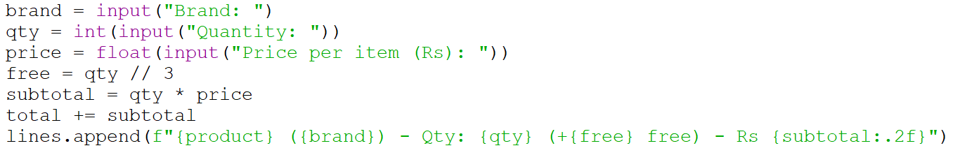

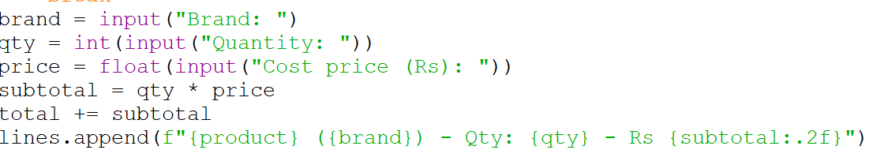

iv. Dictionary

Dictionary is a type of built-in python data which is used to keep key value pairs. It enables a user to assign different keys to a value which makes a data easier to access, alter or change.
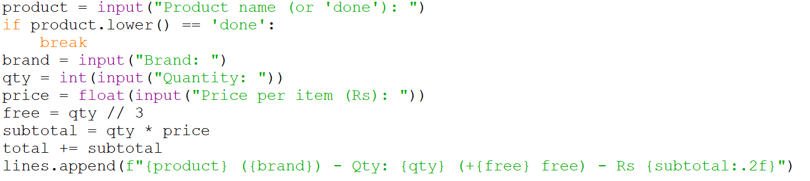

iv. Tuples
Tuples are the collection of elements which are immutable in nature .This elements are generally fixed in their position. The meaning of immutable means it can’t be changed once it is created. Tuples can be denoted by parenthesis (). The performance of the tuple is faster than list. The example are as follows:
Women = (“sita”, 27,”Teacher”)
Print (Women [0])

v. Sets

Sets are the collection of unique items which are unordered and doesn’t allow duplication. This data type is mutable in nature which gives the ability to remove or add items . They are denote by using curly braces {} as well as the set () function.For example mountain = {“everest”,”mt k2”,”kailash”}
print(mountain)

3. Program

3.1 Implementation
The system is developed using python by creating four separate files and they are:

read.py = the read.py operates the entire data’s operations. It reads the product data from the products.txt file .Maintaining error handling altering the data which are raw in a structured format. Program also displays product in a tabular form while handling the vacant lists of product smoothly and at the last it provides overall information.

operation.py = this operation file contains the primary operation for the business with shared functions for utility .It contains buying, selling, displaying, as well as restocking products.

write.py = The file write mainly targets in invoice generation for sales and restock along with functions like handling transactions of suppliers .This program is launched with the help of main file it also displays the products, and records the sales transactions. It also helps in restocking, recording and saving the data and later on generate invoices and at last there is feature exit the operation. This file also includes error handling, offers, and inventory management.

main.py = this file plays a role like a door as well as the main point of the application. It implements menu driven interface to enable the users to clear the options. Next routing function to connect the application to enable users to select desired module. It also enables the continuous running of the system until it is exited.

Algorithm

Step 1: Start
Step 2: Display welcome message
Step 3: input userchoice
Step 4: if userchoice == 1 then goto 10
Step 5: elif userchoice == 2 then goto 20
Step 6: elif userchoice == 3 then goto 30
Step 7: else print invalid choice message
Step 8: goto 3

Step 10: Display table headers
Step 11: For each product in data: print name, brand, stock, price, origin
Step 12: goto 3

Step 20: input customer name
Step 21: input product name
Step 22: if product name not in data then print “Product not found”
Step 23: goto 3
Step 24: input quantity
Step 25: calculate free_items = quantity ÷ 3
Step 26: calculate total_quantity = quantity + free_items
Step 27: if total_quantity > stock then print “Not enough stock”
Step 28: goto 3
Step 29: update stock = stock - total_quantity
Step 30: calculate total_cost = quantity × unit price
Step 31: prepare item list (product, quantity, cost)
Step 32: call generate_invoice()
Step 33: print “Invoice generated successfully”
Step 34: goto 3

Step 30: Exit program
Step 31: End

Pseudo Code

Main.py
IMPORT read_products from read.py
IMPORT generate_invoice from write.py
IMPORT display_products, sell_product from operations.py

CALL read_products("products.txt") → products

LOOP indefinitely:
DISPLAY menu:
1. Display Products
2. Sell Product
3. Exit

PROMPT user to enter choice

IF choice == 1:
CALL display_products(products)

ELSE IF choice == 2:
CALL sell_product(products)

ELSE IF choice == 3:
DISPLAY "Exiting Program"
BREAK

ELSE:
DISPLAY "Invalid option"

Operations.py
FUNCTION display_products(products):
PRINT table headers: Product, Brand, Stock, Price, Origin
FOR each product_name IN products:
GET product details: brand, stock, price, origin
PRINT all values formatted in a row

FUNCTION sell_product(products):
PROMPT user to enter customer name → customer
SET date ← today's date

CALL display_products(products)

PROMPT "Enter Product Name to Buy:" → product_name
IF product_name NOT IN products:
DISPLAY "Product not found"
RETURN

PROMPT "Enter Quantity to Buy:" → quantity
CONVERT quantity TO integer

SET stock ← products[product_name]["stock"]
SET price ← products[product_name]["cost_price"]

CALCULATE free_items ← quantity DIV 3
CALCULATE total_quantity ← quantity + free_items

IF total_quantity > stock:
DISPLAY "Not enough stock available"
RETURN

UPDATE products[product_name]["stock"] ← stock - total_quantity

CALCULATE total_cost ← quantity × price
CREATE items list with (product_name, quantity, total_cost)

CALL generate_invoice(customer, date, items, total_cost)

DISPLAY "Purchase complete. Invoice generated."

Write.py
FUNCTION generate_invoice(customer, date, items, total):
SET filename AS customer + "_" + date + ".txt"
OPEN filename in write mode AS file:
WRITE invoice header with customer and date
WRITE table header: Product, Quantity, Cost
FOR each item IN items:
WRITE product name, quantity, and cost
WRITE total amount at the bottom
CLOSE file

Read.py
FUNCTION read_products(filename):
INITIALIZE empty dictionary called products
OPEN file with name filename in read mode AS file:
FOR each line IN file:
STRIP newline character from line
SPLIT line by commas INTO name, brand, stock, cost_price, origin
CONVERT stock TO integer and cost_price TO float
STORE these values in dictionary format
ADD product to products dictionary with name as key
RETURN products

Flow Chart
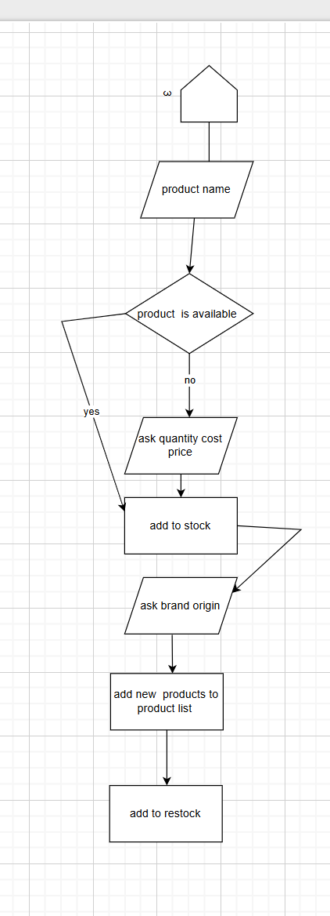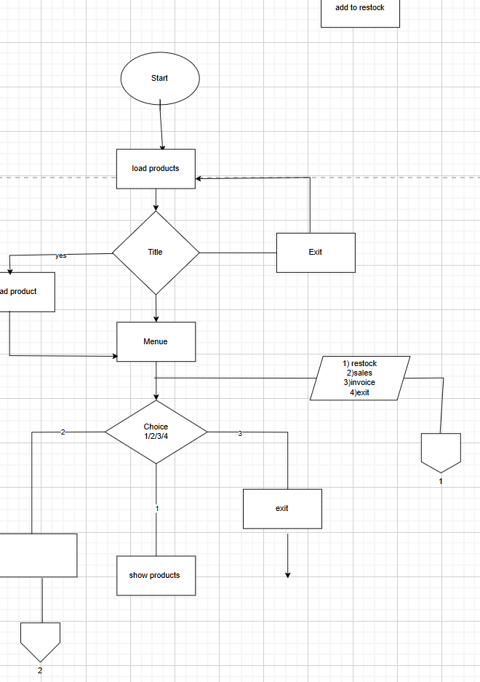

Testing: try and except implementation
Objective | To handle invalid inputs
Action | We intered invalid input in names
Expected result | The message invalid customer name will appera
Actual result | As expected the message appeared
Conclusion | Succrss ful

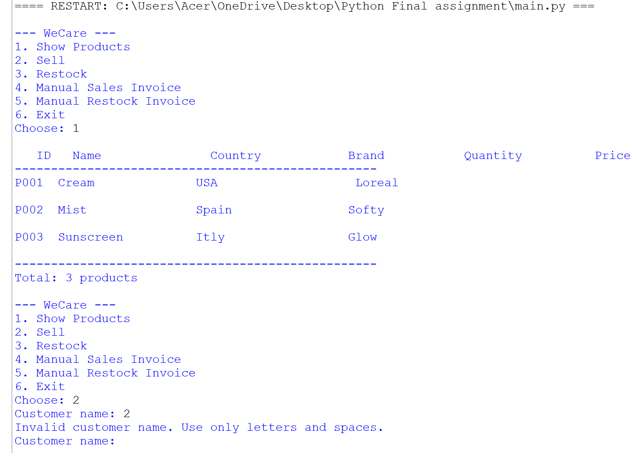

Testing 2: Entering negative value in buying selling
Objective | To inter negative value in cost
Action | We intered negative cost value
Desired Result | The message stating negative value will appear
Actual result | As expected the Message successfully came
Conclusion | Successful
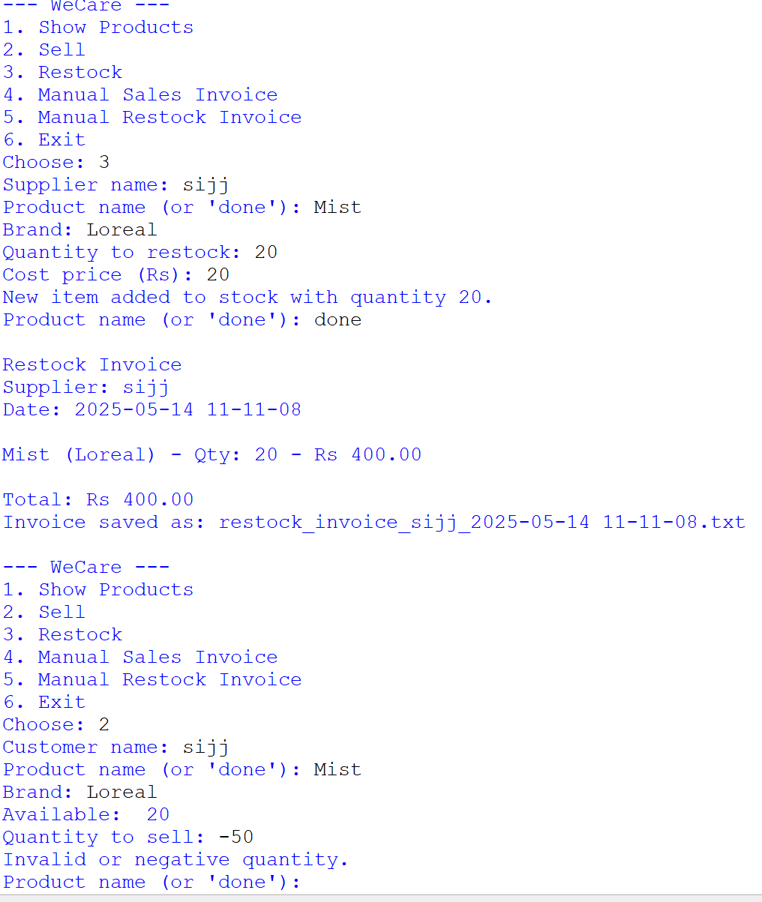

Testing3:Non existing value
Objective | To chek if the program supports invalid value.
Action | We entered invalid value
Desired Output | Out put product not found to display
Actual Output | AS expected the same output came
Conclusion | success
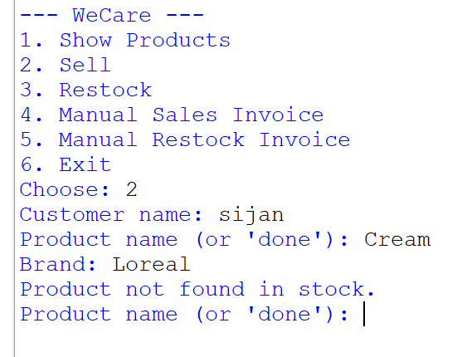

Testing 4: testing multiple purchase
Objective | To buy multiple products
Action | Tried to buy multiple products
Desired Output | Able to buy multiple products
Actual Output | Were able to buy multiple product
Conclusion | Successful

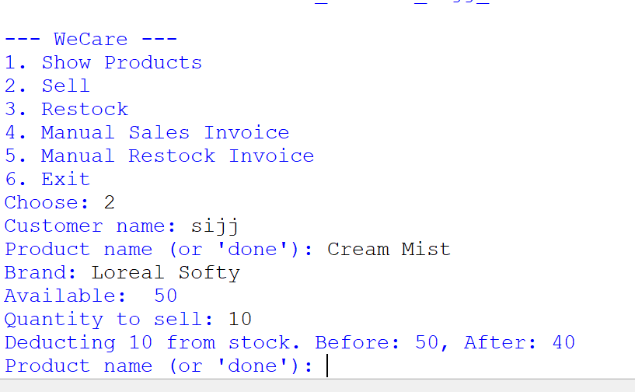

Testing5:Restocking multiple products
Objective | To restock multiple products
Action | Restocking both products
Desired Output | Able to Restock multiple products
Actual Output | Multiple product added
Conclusion | Successful
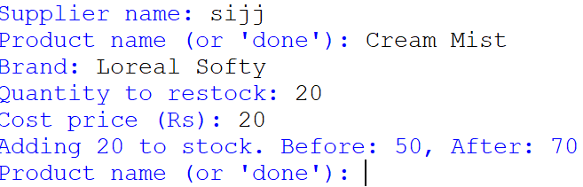

Appendix

Read.py
def load_products():
try:
with open("products.txt", "r") as f:
products = []
for line in f:
parts = line.split(',')
if len(parts) == 4:
products.append({
'id': parts[0],
'name': parts[1],
'country': parts[2],
'brand': parts[3],
'price': 0.0,
'quantity': 0
})
return products
except FileNotFoundError:
print("products file not found")
return []
except ValueError:
print("Error in file format")
return []
#if the product is not available
def show_products(products):
if not products:
print("No products available")
return

print("\n ID Name Country Brand Quantity Price ")
print("-" * 50)

for p in products:
line = p['id'].ljust(4) + " " + p['name'].ljust(18) + " " + p['country'].ljust(21) + " " + p['brand']
print(line)

print("-" * 50)
print("Total: " + str(len(products)) + " products")

if __name__ == "__main__":
show_products(load_products())

write.py
import datetime

def get_now():
return datetime.datetime.now().strftime("%Y-%m-%d %H-%M-%S")
#asking the require fields
def sales_invoice():
name = input("Customer name: ")
filename = f"sales_invoice_{name}_{get_now()}.txt"
total = 0
lines = [f"Sales Invoice", f"Customer: {name}", f"Date: {get_now()}\n"]

while True:
product = input("Product name (or 'done'): ")
if product.lower() == 'done':
break
brand = input("Brand: ")
qty = int(input("Quantity: "))
price = float(input("Price per item (Rs): "))
free = qty // 3
subtotal = qty * price
total += subtotal
lines.append(f"{product} ({brand}) - Qty: {qty} (+{free} free) - Rs {subtotal:.2f}")

lines.append(f"\nTotal: Rs {total:.2f}")
content = "\n".join(lines)

print("\n" + content)
with open(filename, "w") as f:
f.write(content)
print("\nInvoice saved as:" +filename)

def restock_invoice():
name = input("Supplier name: ")
filename = f"restock_invoice_{name}_{get_now()}.txt"
total = 0
lines = [f"Restock Invoice", f"Supplier: {name}", f"Date: {get_now()}\n"]

while True:
product = input("Product name (or 'done'): ")
if product.lower() == 'done':
break
brand = input("Brand: ")
qty = int(input("Quantity: "))
price = float(input("Cost price (Rs): "))
subtotal = qty * price
total += subtotal
lines.append(f"{product} ({brand}) - Qty: {qty} - Rs {subtotal:.2f}")

lines.append(f"\nTotal: Rs {total:.2f}")
content = "\n".join(lines)

print("\n" + content)
with open(filename, "w") as f:
f.write(content)
print("\nInvoice saved as:" + filename)

# formindg a manue
if __name__ == "__main__":
print("1. Sales Invoice")
print("2. Restock Invoice")
option = input("Choose (1 or 2): ")

if option == '1':
sales_invoice()
elif option == '2':
restock_invoice()
else:
print("Invalid choice.")

operations.py
import datetime
import csv

STOCK_FILE = "stock.txt"

def get_now():
return datetime.datetime.now().strftime("%Y-%m-%d %H-%M-%S")

def load_stock():
stock = {}
try:
with open(STOCK_FILE, newline='') as f:
reader = csv.DictReader(f)
for row in reader:
key = (row['product'].lower(), row['brand'].lower())
stock[key] = {
'product': row['product'],
'brand': row['brand'],
'quantity': int(row['quantity']),
'price': float(row['price'])
}
except FileNotFoundError:
with open(STOCK_FILE, 'w') as f:
f.write("product,brand,quantity,price\n")
except Exception as e:
print("Error loading stock:", e)
return stock

def save_stock(stock):
try:
with open(STOCK_FILE, 'w', newline='') as f:
writer = csv.DictWriter(f, fieldnames=['product', 'brand', 'quantity', 'price'])
writer.writeheader()
for item in stock.values():
writer.writerow(item)
except Exception as e:
print("Error saving stock:", e)

def show_products():
stock = load_stock()
if not stock:
print("Stock is empty.")
return
print("\nCurrent Stock:\n")
print("Product Brand Qty Price (Rs)")
print("-" * 50)
for item in stock.values():
print(f"{item['product']:15} {item['brand']:15} {item['quantity']:10} {item['price']:10.2f}")

def is_valid_name(name):
return name.replace(" ", "").isalpha()

def is_valid_number(value):
try:
val = float(value)
return val >= 0
except:
return False

def sales_invoice():
stock = load_stock()

while True:
name = input("Customer name: ").strip()
if is_valid_name(name):
break
else:
print("Invalid customer name. Use only letters and spaces.")

filename = "sales_invoice_" + name + "_" + get_now() + ".txt"
total = 0
lines = ["Sales Invoice", "Customer: " + name, "Date: " + get_now() + "\n"]

while True:
try:
product = input("Product name (or 'done'): ").strip()
if product.lower() == 'done':
break
if not is_valid_name(product):
print("Invalid product name.")
continue

brand = input("Brand: ").strip()
if not is_valid_name(brand):
print("Invalid brand name.")
continue

key = (product.lower(), brand.lower())
if key not in stock:
print("Product not found in stock.")
continue

available = stock[key]['quantity']
print("Available: ", available)

qty_input = input("Quantity to sell: ")
if not qty_input.isdigit() or int(qty_input) <= 0:
print("Invalid or negative quantity.")
continue

qty = int(qty_input)
if qty > available:
print("Not enough stock.")
continue

price = stock[key]['price']
free = qty // 3
subtotal = qty * price
total += subtotal

print(f"Deducting {qty} from stock. Before: {available}, After: {available - qty}")
stock[key]['quantity'] -= qty

lines.append(f"{product} ({brand}) - Qty: {qty} (+{free} free) - Rs {subtotal:.2f}")
#adding the cryteria for the data entered
except Exception as e:
print("Error during sales entry:", e)

lines.append("\nTotal: Rs {:.2f}".format(total))
content = "\n".join(lines)

print("\n" + content)
try:
with open(filename, "w") as f:
f.write(content)
print("Invoice saved as:", filename)
except Exception as e:
print("Error saving invoice:", e)

save_stock(stock)

def restock_invoice():
stock = load_stock()

while True:
name = input("Supplier name: ").strip()
if is_valid_name(name):
break
else:
print("Invalid supplier name.")

filename = "restock_invoice_" + name + "_" + get_now() + ".txt"
total = 0
lines = ["Restock Invoice", "Supplier: " + name, "Date: " + get_now() + "\n"]

while True:
try:
product = input("Product name (or 'done'): ").strip()
if product.lower() == 'done':
break
if not is_valid_name(product):
print("Invalid product name.")
continue

brand = input("Brand: ").strip()
if not is_valid_name(brand):
print("Invalid brand name.")
continue

qty_input = input("Quantity to restock: ")
price_input = input("Cost price (Rs): ")

if not qty_input.isdigit() or int(qty_input) <= 0:
print("Invalid or negative quantity.")
continue
if not is_valid_number(price_input):
print("Invalid or negative price.")
continue

qty = int(qty_input)
price = float(price_input)
key = (product.lower(), brand.lower())

if key in stock:
before_qty = stock[key]['quantity']
stock[key]['quantity'] += qty
stock[key]['price'] = price
print(f"Adding {qty} to stock. Before: {before_qty}, After: {stock[key]['quantity']}")
else:
stock[key] = {
'product': product,
'brand': brand,
'quantity': qty,
'price': price
}
print(f"New item added to stock with quantity {qty}.")

subtotal = qty * price
total += subtotal
lines.append(f"{product} ({brand}) - Qty: {qty} - Rs {subtotal:.2f}")

except Exception as e:
print("Error during restocking:", e)

lines.append("\nTotal: Rs {:.2f}".format(total))
content = "\n".join(lines)

print("\n" + content)
try:
with open(filename, "w") as f:
f.write(content)
print("Invoice saved as:", filename)
except Exception as e:
print("Error saving invoice:", e)

save_stock(stock)

def sell_product():
try:
sales_invoice()
except Exception as e:
print("Error in sell_product:", e)

def restock_product():
try:
restock_invoice()
except Exception as e:
print("Error in restock_product:", e)

main.py
from read import load_products, show_products
from write import sales_invoice, restock_invoice
from operations import sell_product, restock_product
#accessing every thing
def main():
while True:
print("\n--- WeCare ---")
print("1. Show Products")
print("2. Sell")
print("3. Restock")
print("4. Manual Sales Invoice")
print("5. Manual Restock Invoice")
print("6. Exit")

c = input("Choose: ")

if c == '1':
show_products(load_products()) # smave visible the available
elif c == '2':
sell_product() # when the product is selled its updated
elif c == '3':
restock_product() # same as above restocking and updating the stocks
elif c == '4':
sales_invoice() # creating invoices requiees for sales
elif c == '5':
restock_invoice() # same as sales generating the invoice for restock
elif c == '6':
break # Exit the program
else:
print("Invalid choice")

if __name__ == "__main__":
main()

Conclusion

